AUTUMN (Tamper-evident GOLD cap)  50ml - $1.60/btl (48/cs.) 18mm  100ml - $3.50/btl (12/cs.) 24mm  250ml - $5.00/btl (12/cs.) 24mm  500ml -$6.25/btl (12/cs.) 28mm | 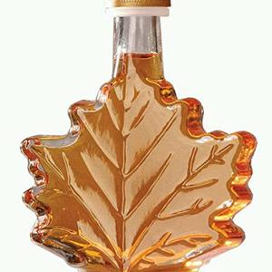
CLASSIC BARREL (Tamper-evident GOLD cap)  125ml - $1.85/btl. (35/cs.) 24mm  250ml - $2.15/btl. (24/cs.) 24mm | 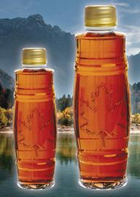
CURVED KENT (Tamper-evident BLACK cap)  250ml - $14/cs. (12/cs.) 28mm ($1.17/btl)  375ml -$18/cs. (12/cs.) 28mm ($1.50/btl)  500ml - $18/cs. (12/cs.) 28mm ($1.50/btl) | 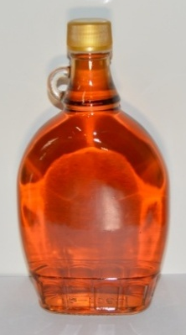
ERABLE (Tamper-evident GOLD cap)  250ml - $2.50/btl (12/cs.) 28mm | 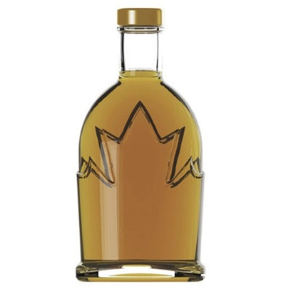
GINGERBREAD (Tamper-evident GOLD cap)  50ml - $1.50/btl(48/cs.) 18mm  100ml - $2.50/btl (24/cs.) 24mm | 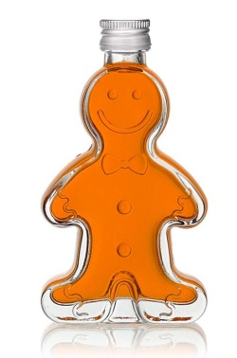
MAPLE (Tamper-evident GOLD cap)  375ml - $3.75/btl (12/cs.) 28-400mm  ** LIQUIDATION ** | 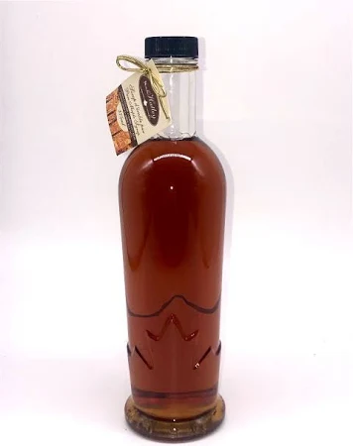
MEDALION (Tamper-evident GOLD cap)  50ml - $1.25/btl (48/cs.) 18mm  250ml - $4.50/btl (12/cs.) 24mm | 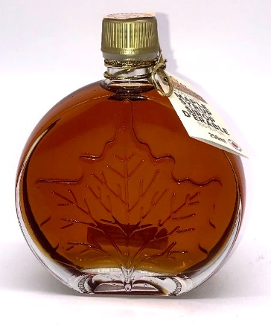
ROUND (Tamper-evident BLACK cap)  1 LITRE - $25/cs. (12/cs.) 28mm ($2.08/btl) | 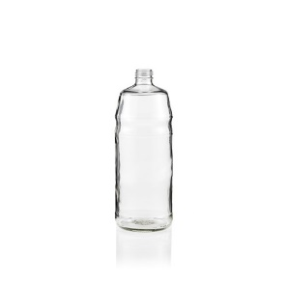
WHISKEY (28x400 BLACK cap)  1 LITRE - $28/cs. (12/cs.) 28mm ($2.33/btl) | 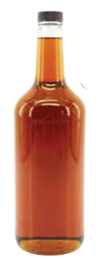
GLASS JARS (43,48 or 70mm GOLD cap)  41ml - $0.40/jar (160/cs.) 43mm  125ml - $8/cs. (12/cs.) 48mm  250ml - $12/cs. (12/cs.) 70mm  375ml - $13/cs.(12/cs.) 70mm | 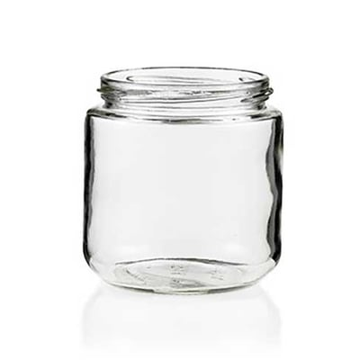  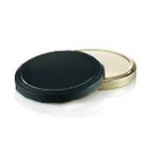
OMSPA JUGS (same caps for all sizes, except 100ml)  100ml - $110/cs. (100/cs.) if sold per unit, $1.25/jug  250ml - $120/cs. (100/cs.) if sold per unit, $1.40/jug  500ml -$140/cs. (100/cs.) if sold per unit, $1.60/jug  1L-$160/cs. (100/cs.) if sold per unit, $1.80/jug  2L –$120/cs. (50/cs.) if sold per unit, $2.75/jug  4L -$82/cs. (24/cs.) if sold per unit, $3.75/jug | 